David Willis

Lingma Acheson

CIT 304

4.6.18

Course Project 7

Query Parts 1 – 6

CREATE TABLE EMPLOYEE (

employee_id varchar2(8) not null,

last_name varchar2(40),

first_name varchar2(40),

middle_initial varchar2(1),

dept_id varchar2(4),

title varchar2(40),

supervisor_id varchar2(8),

PRIMARY KEY (employee_id),

CONSTRAINT FK_emp_emp FOREIGN KEY (supervisor_id)

REFERENCES EMPLOYEE (employee_id),

CONSTRAINT FK_emp_dept FOREIGN KEY (dept_id)

REFERENCES DEPARTMENT (dept_id)

);

CREATE TABLE DEPARTMENT (

dept_id varchar2(4) not null,

division_name varchar2(20),

department_name varchar2(20),

PRIMARY KEY (dept_id)

);

set define off

INSERT INTO DEPARTMENT VALUES('EBX', 'Pharma', 'R&D');

INSERT INTO DEPARTMENT VALUES('CP1', 'Corporate', 'Finance');

INSERT INTO DEPARTMENT VALUES('CP2', 'Corporate', 'Marketing');

set define on

INSERT INTO EMPLOYEE VALUES('EB001', 'Abbott', 'Richard', null, 'EBX', 'Director', null);

INSERT INTO EMPLOYEE VALUES('EB002', 'Johnson', 'Fred', null, 'EBX', 'Manager', 'EB001');

INSERT INTO EMPLOYEE VALUES('EB103', 'Searle', 'Jan', null, 'EBX', 'Technician', 'EB002');

INSERT INTO EMPLOYEE VALUES('EB104', 'Lambert', 'Fred', 'W', null, 'Technician', 'EB002');

INSERT INTO EMPLOYEE VALUES('CP001', 'Roche', 'Judith', 'H', 'CP1', 'Director', null);

INSERT INTO EMPLOYEE VALUES('CP002', 'Glaxo', 'Smithy', 'K', 'CP2', 'Director', null);

INSERT INTO EMPLOYEE VALUES('CP003', 'Product', 'Amerigus', 'H', 'CP1', 'Manager', 'CP001');

INSERT INTO EMPLOYEE VALUES('CP004', 'Bayer', 'Helmut', null, 'CP1', 'Dept. Head', 'CP003');

INSERT INTO EMPLOYEE VALUES('CP005', 'Merck', 'Trent', null, 'CP1', 'Team Leader', 'CP004');

INSERT INTO EMPLOYEE VALUES('CP006', 'Baxter', 'Ted', null, 'CP1', 'clerk', 'CP005');

INSERT INTO EMPLOYEE VALUES('CP007', 'Underling', 'John', null, 'CP1', 'clerk', 'CP005');

INSERT INTO EMPLOYEE VALUES('CP008', 'Helper', 'Susan', 'H', null, 'AA', 'CP003');

INSERT INTO EMPLOYEE VALUES('CP009', 'Dilbert', 'Joe', null, 'CP1', 'clerk', 'CP005');

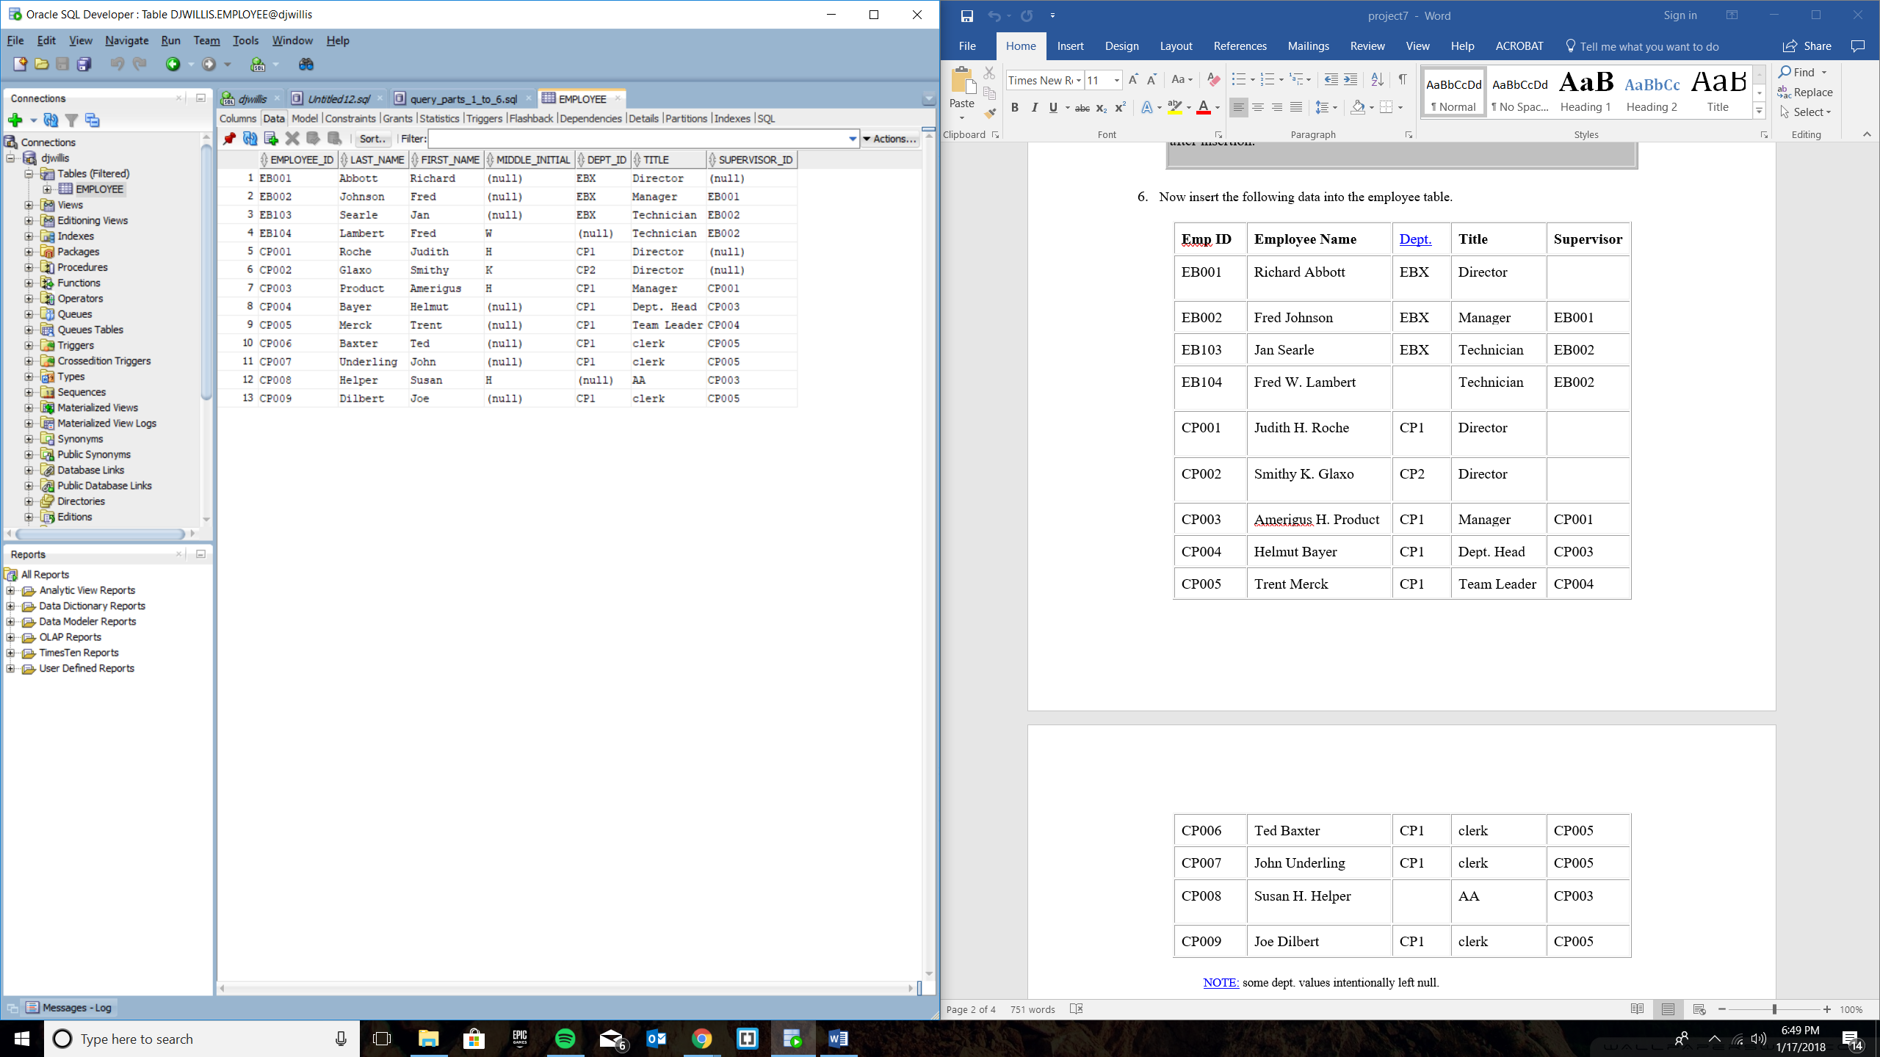

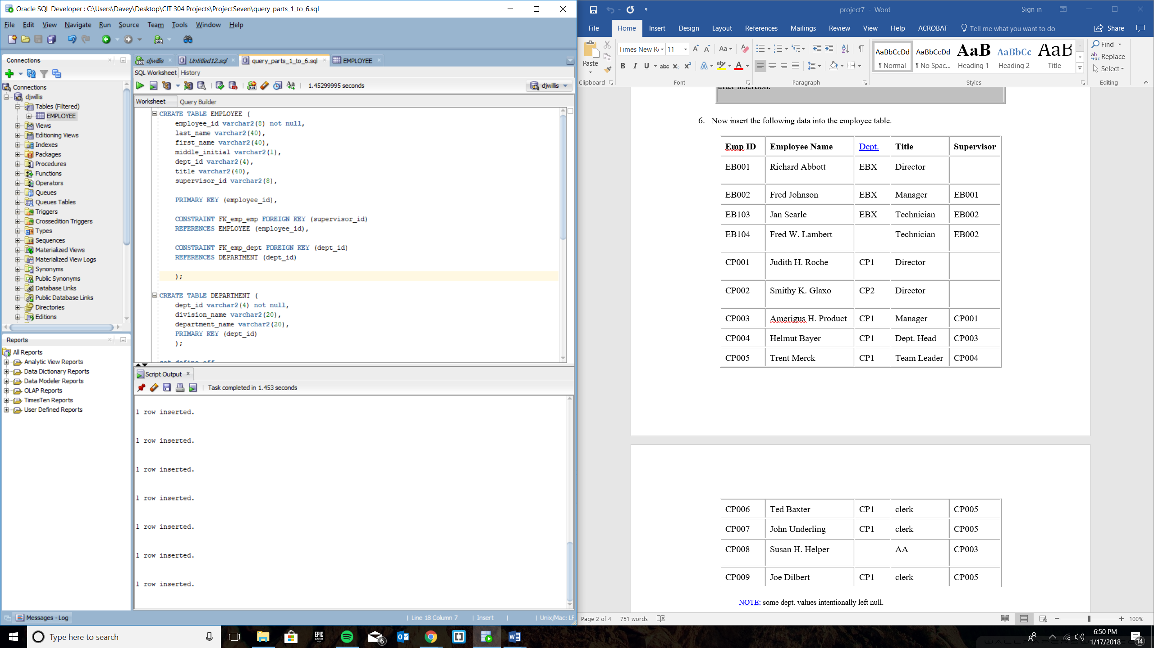

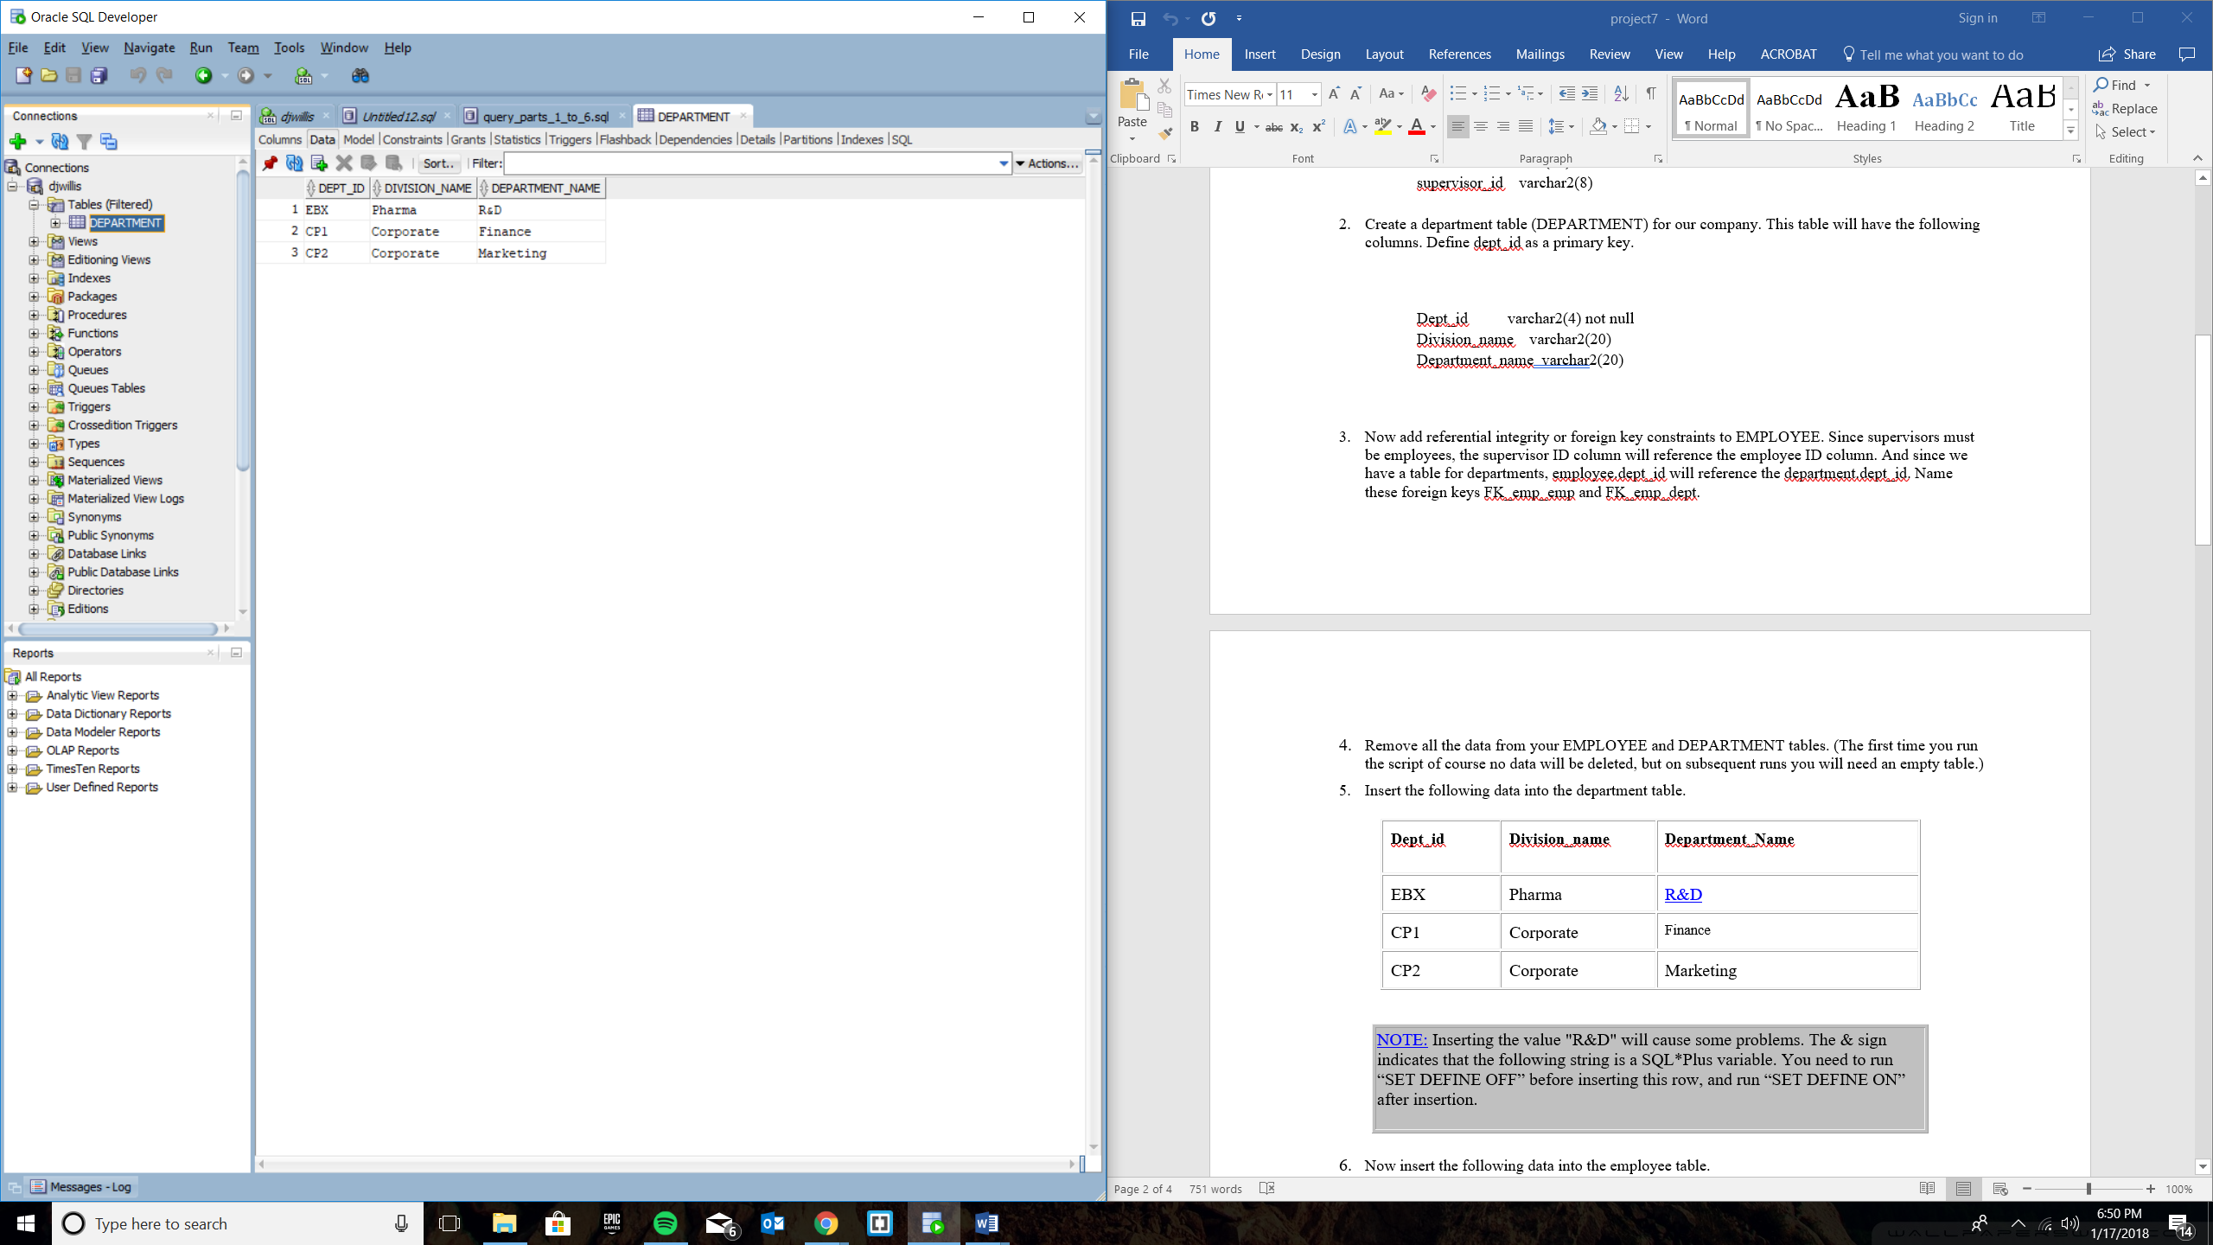

Query Part 7

INSERT INTO EMPLOYEE (employee_id, last_name, first_name, middle_initial, dept_id, title, supervisor_id)

--SELECT RIGHT(NAME, charindex(' ', NAME) - 1) AS last_name,

--LEFT(NAME, charindex(' ', NAME) - 1) AS first_name,

SELECT

substr(NAME,1,3) || ltrim(to_char(nvl(age,1),'009')) as employee_id,

initcap(substr(name,instr(name,' ',1)+1)) as last_name,

initcap(substr(name,1,instr(name,' ',1)-1)) as first_name,

null,

'CP2',

'Salesperson',

'CP002'

FROM WORKER;

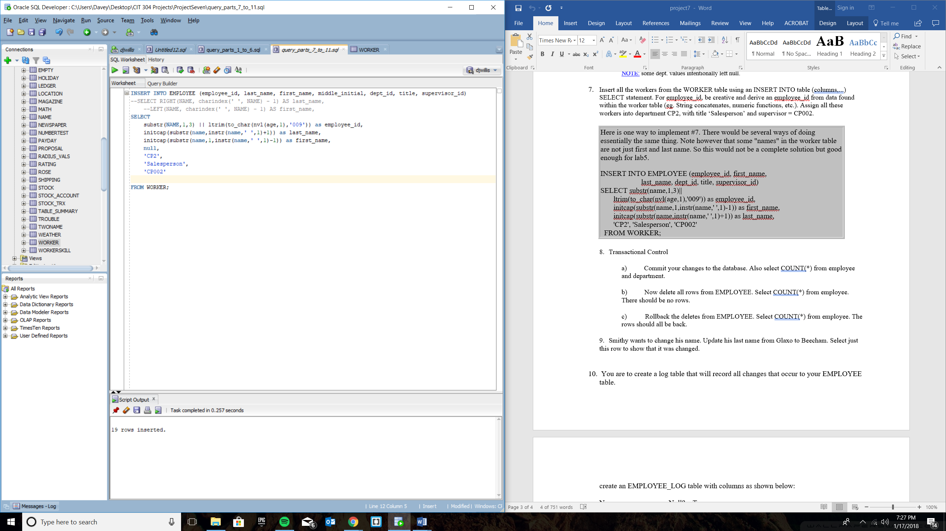

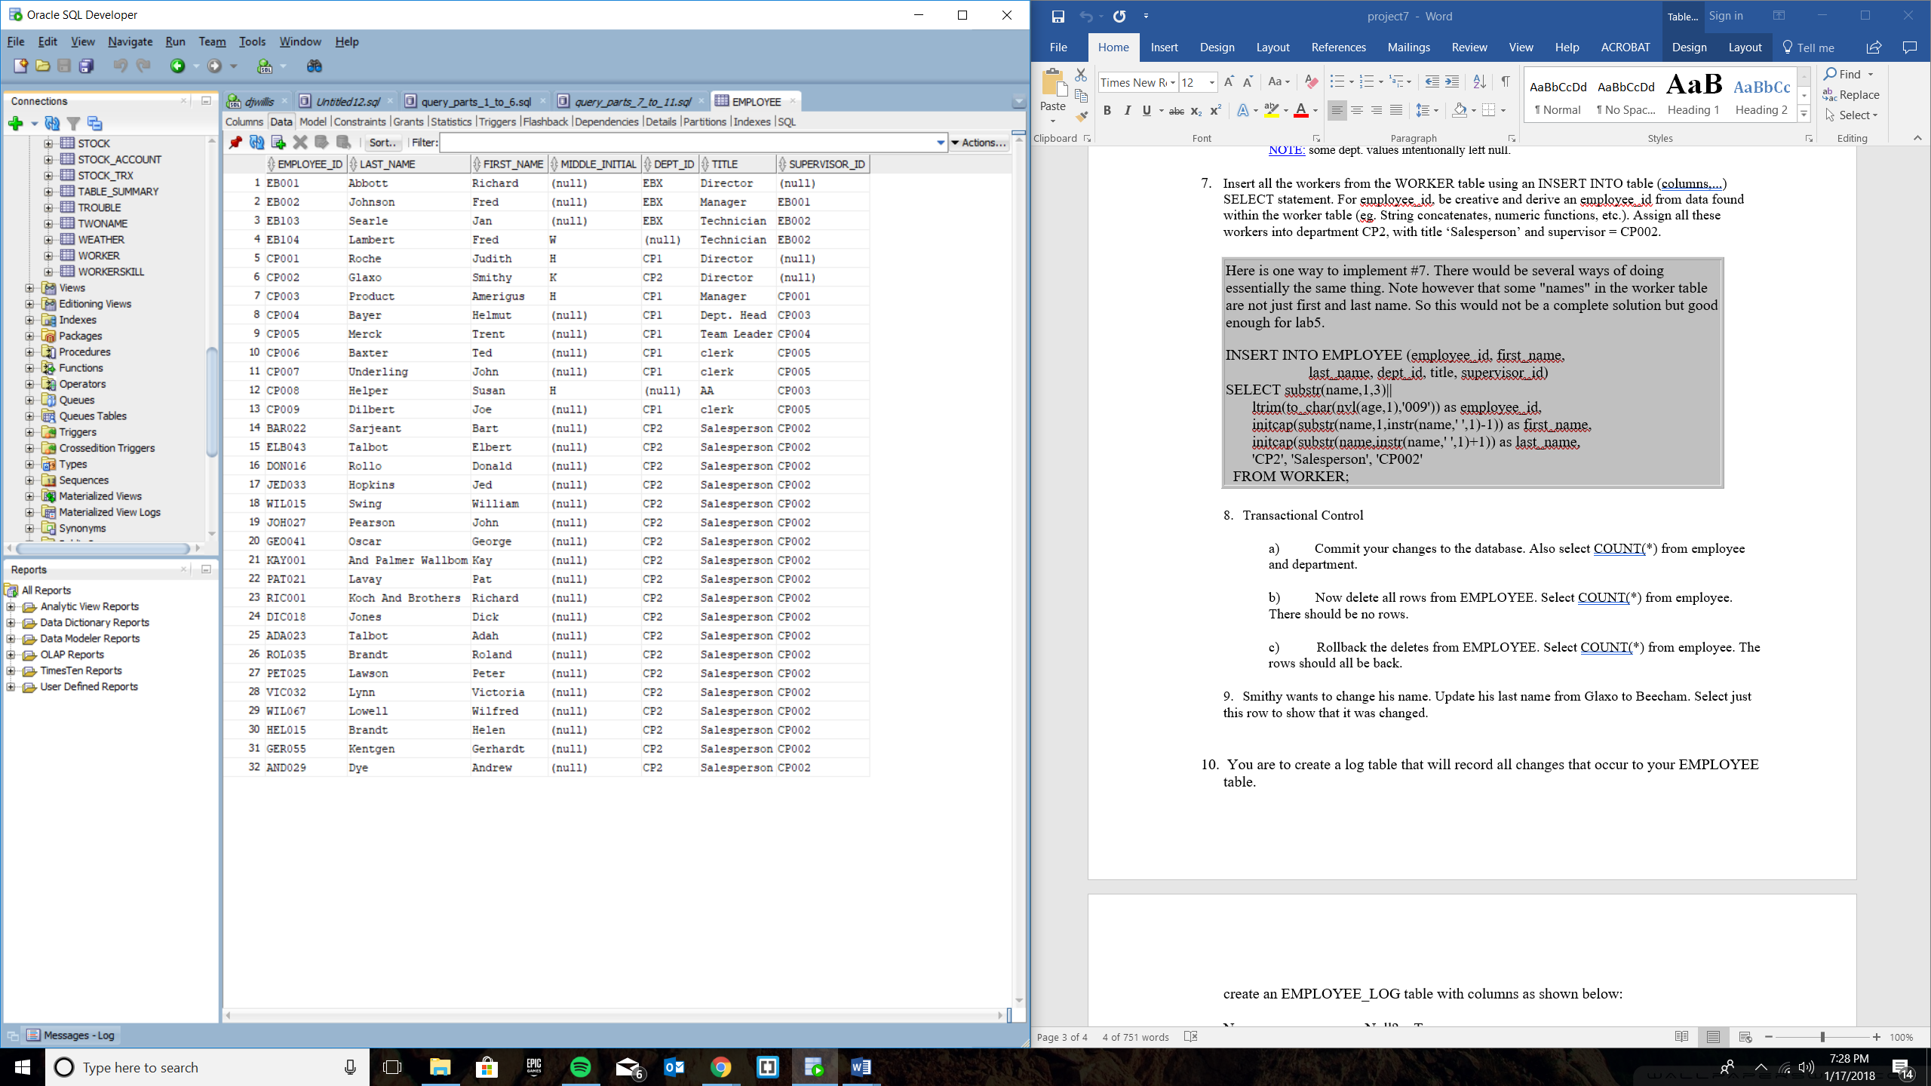

Part 8

8-A

SELECT COUNT(*) FROM EMPLOYEE;

SELECT COUNT(*) FROM DEPARTMENT;

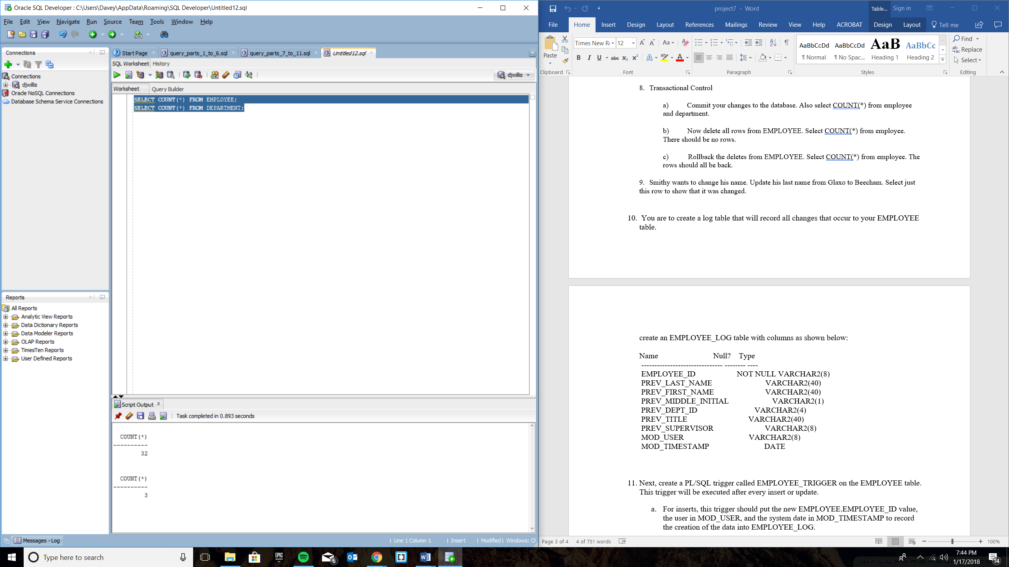

8-B

DELETE FROM EMPLOYEE;

SELECT COUNT(*) FROM EMPLOYEE;

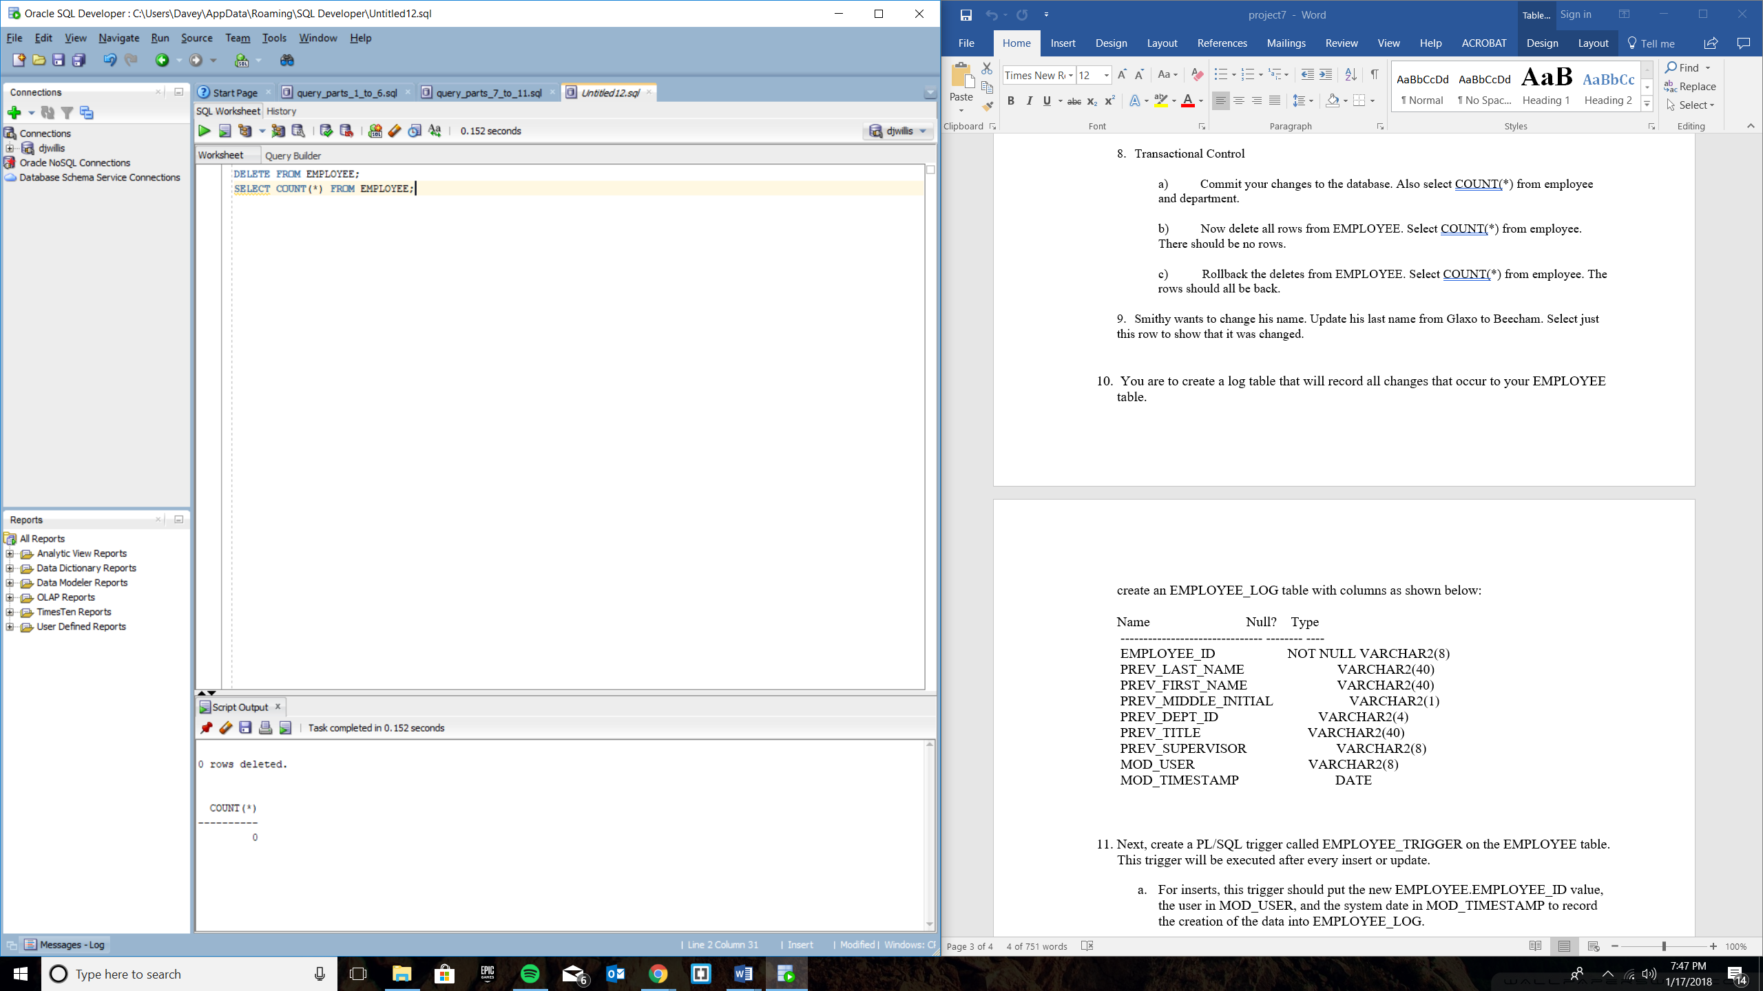

8-C

ROLLBACK;

SELECT COUNT(*) FROM EMPLOYEE;

SELECT * FROM EMPLOYEE;

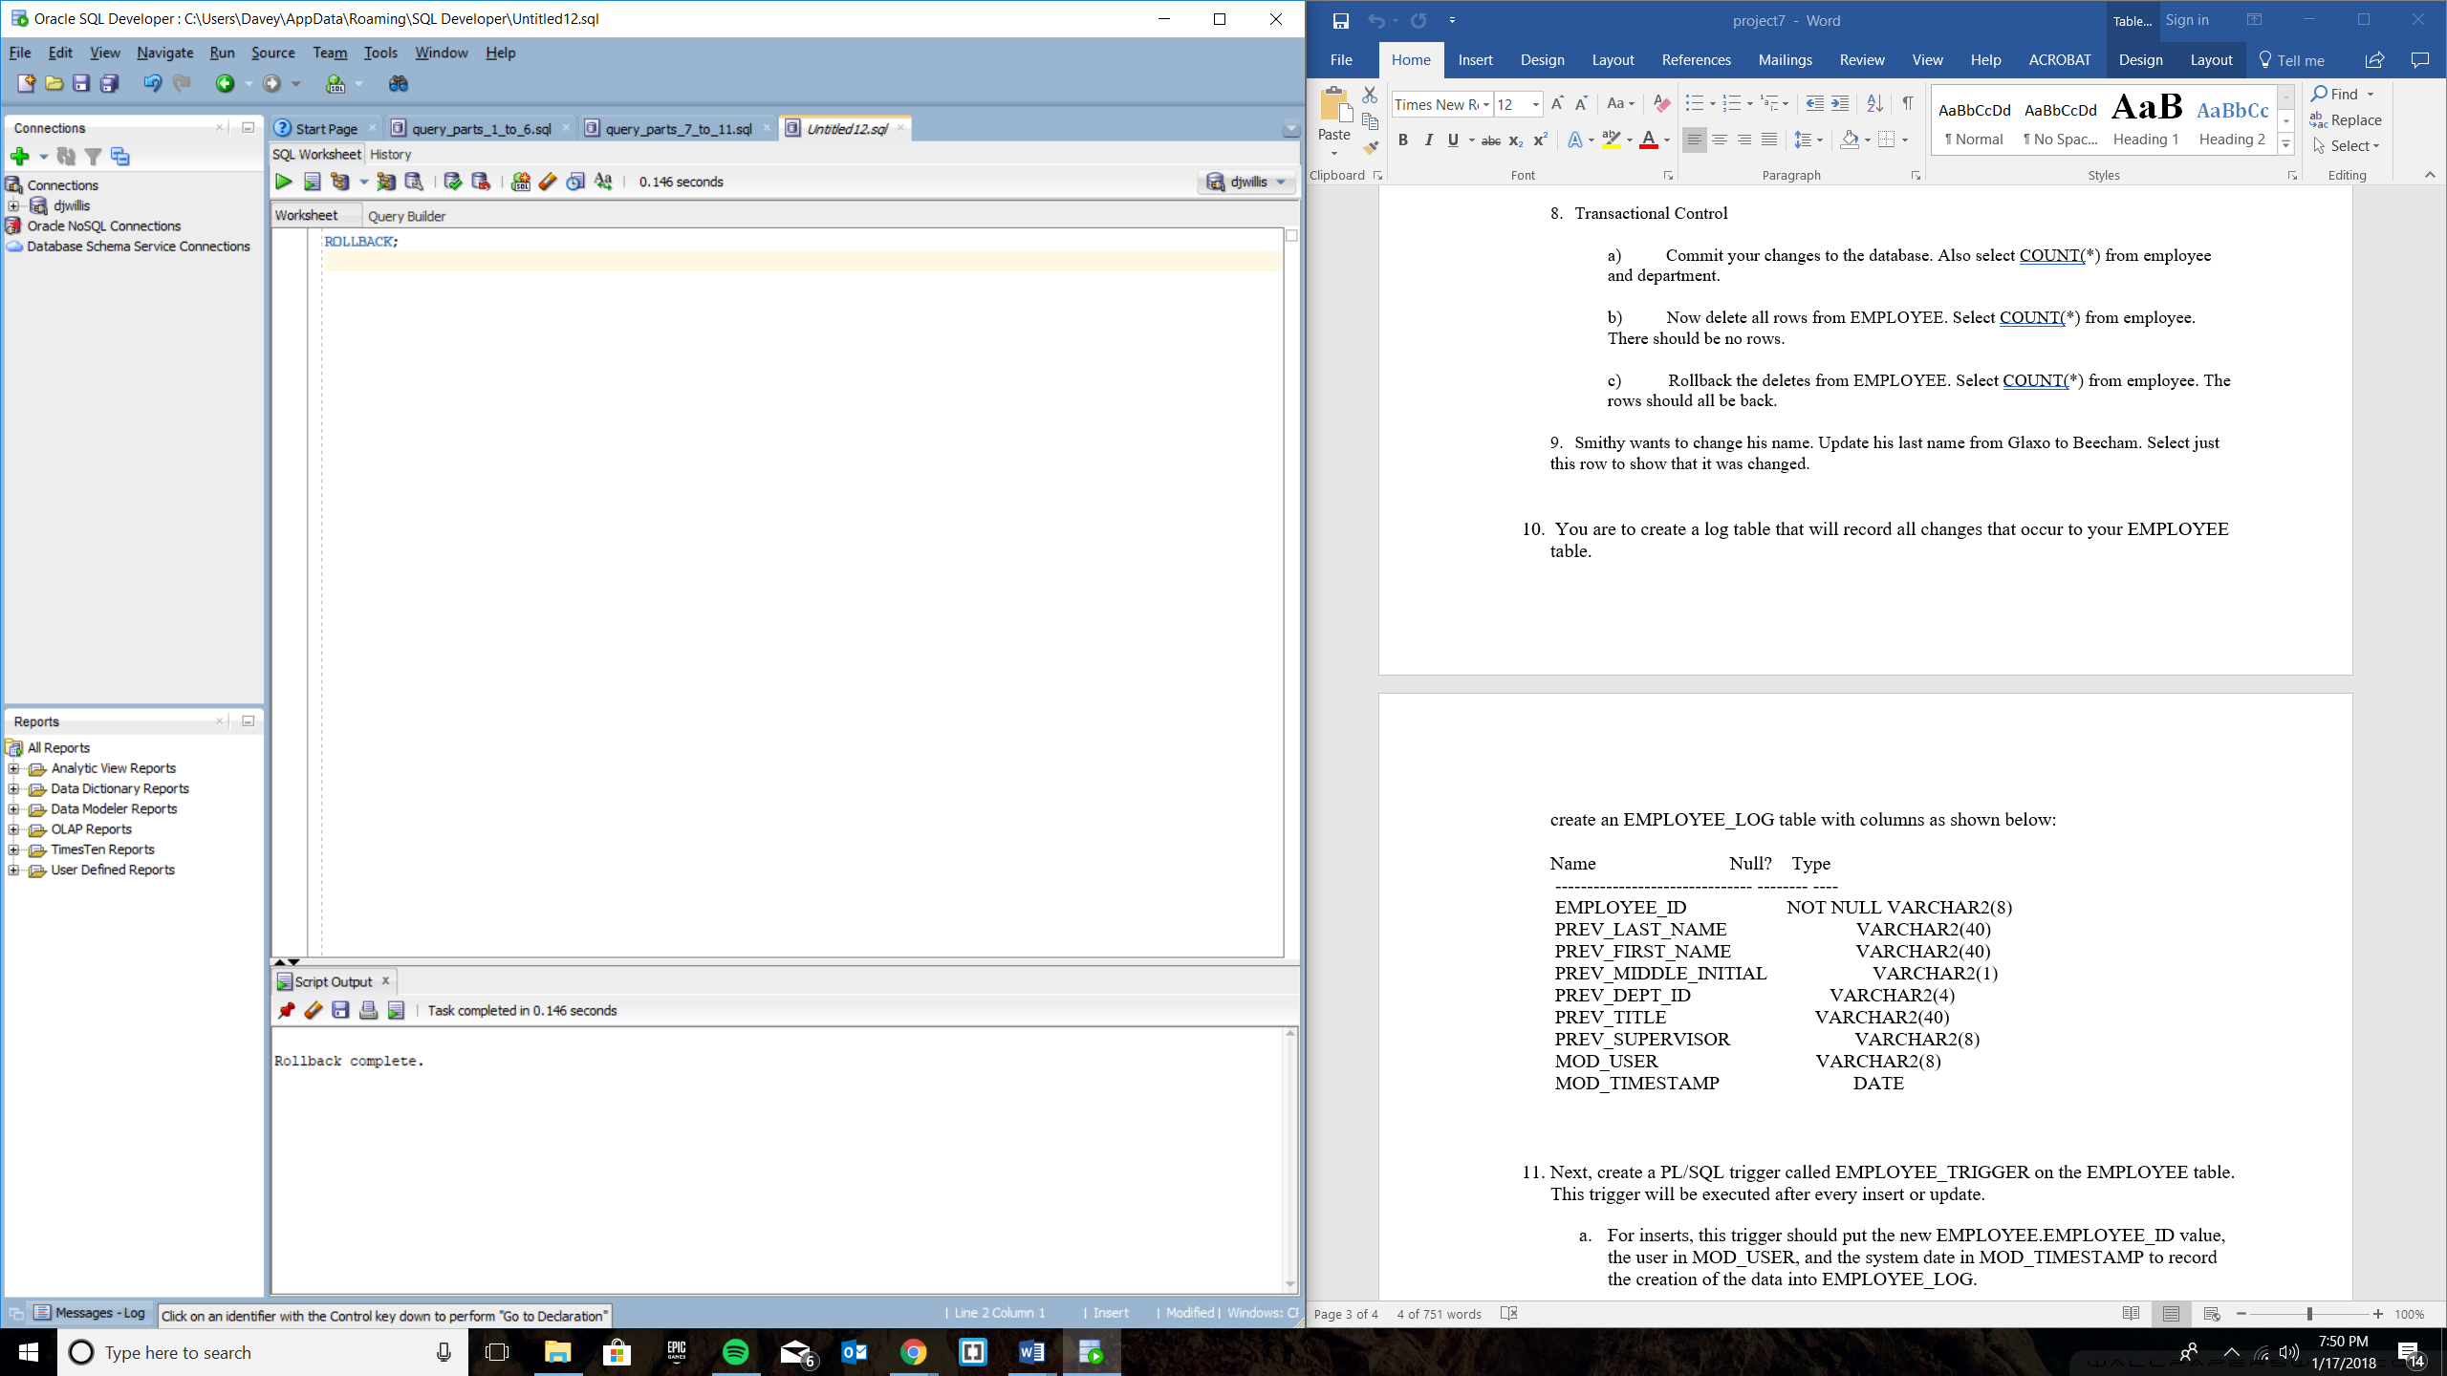

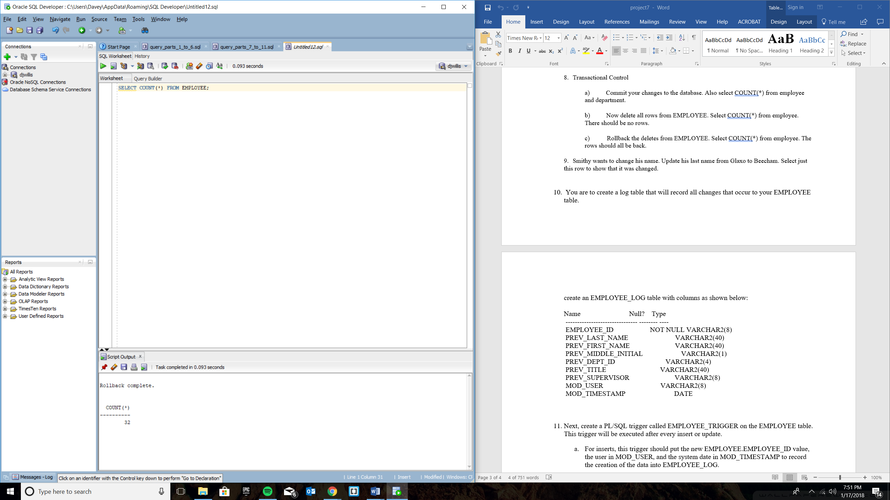

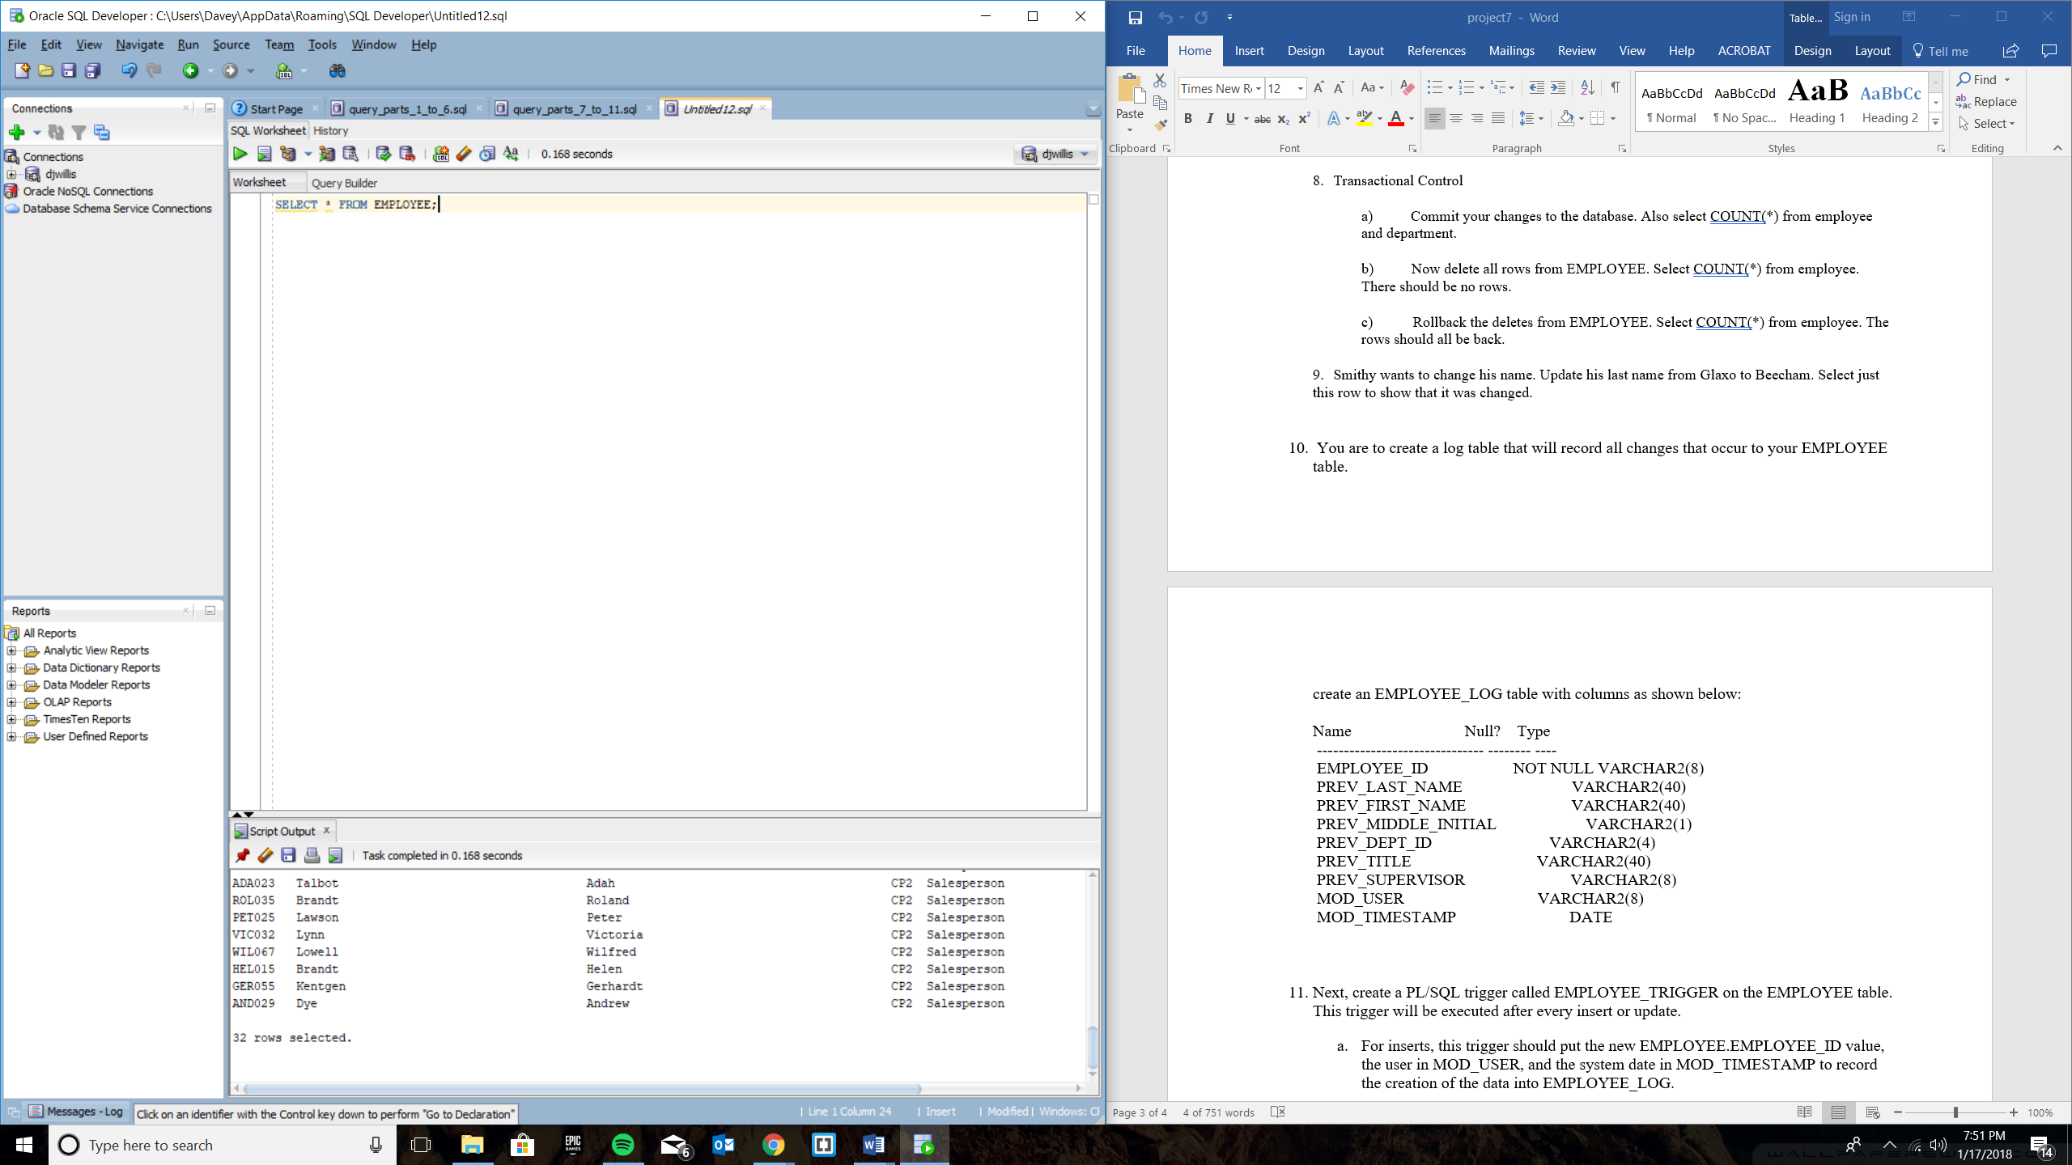

Part 9

UPDATE EMPLOYEE

SET last_name = 'Beecham'

WHERE last_name = 'Glaxo';

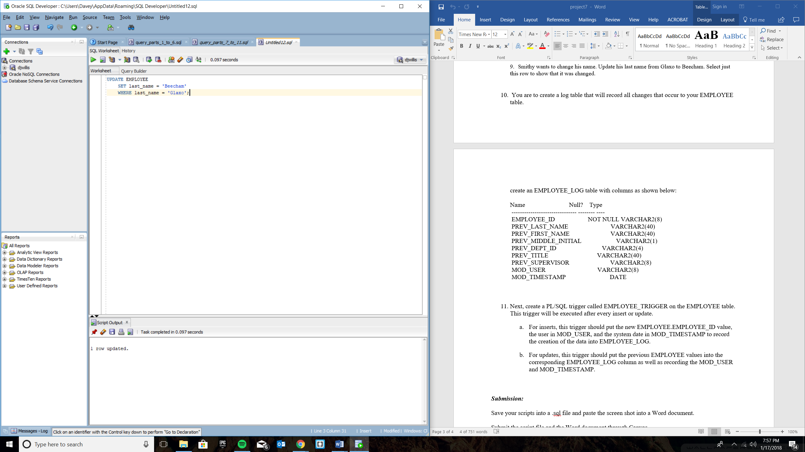

Proof of update:

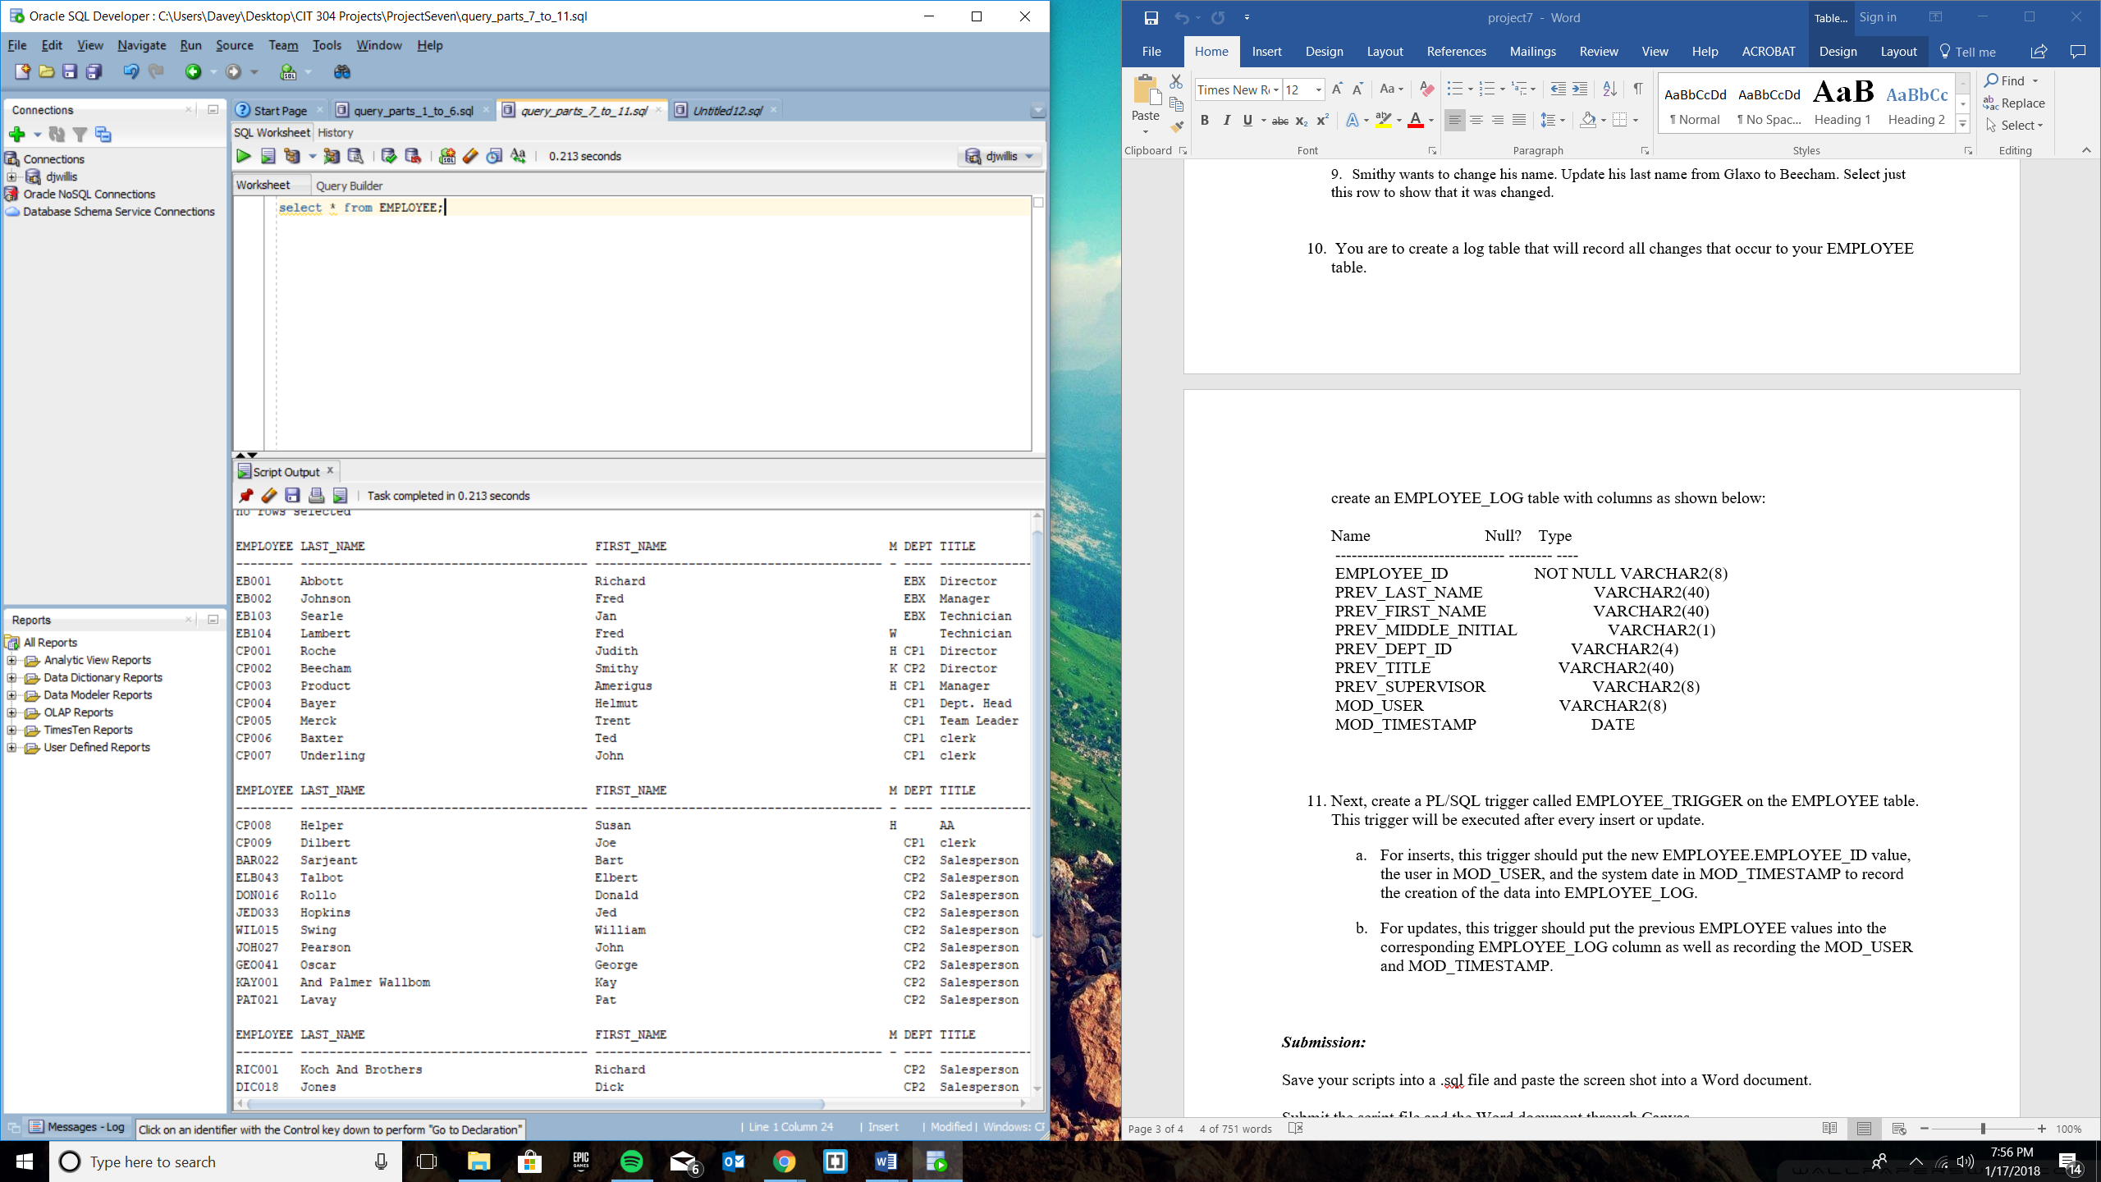

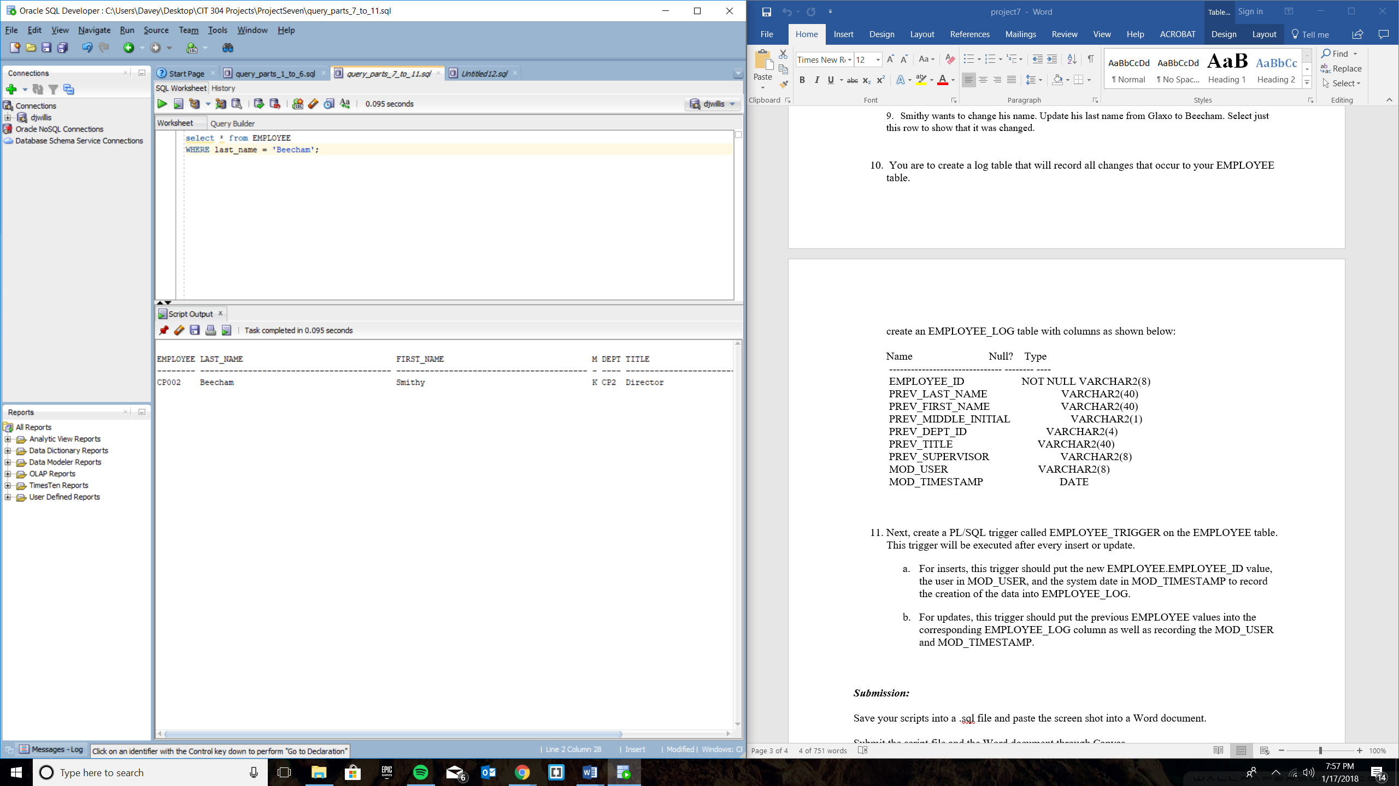

Query Part 10

CREATE TABLE EMPLOYEE_LOG (

employee_id varchar2(8) not null,

prev_last_name varchar2(40),

prev_first_name varchar2(40),

prev_middle_initial varchar2(1),

prev_dept_id varchar2(4),

prev_title varchar2(40),

prev_supervisor_id varchar2(8),

mod_user varchar2(8),

mod_timestamp date

);

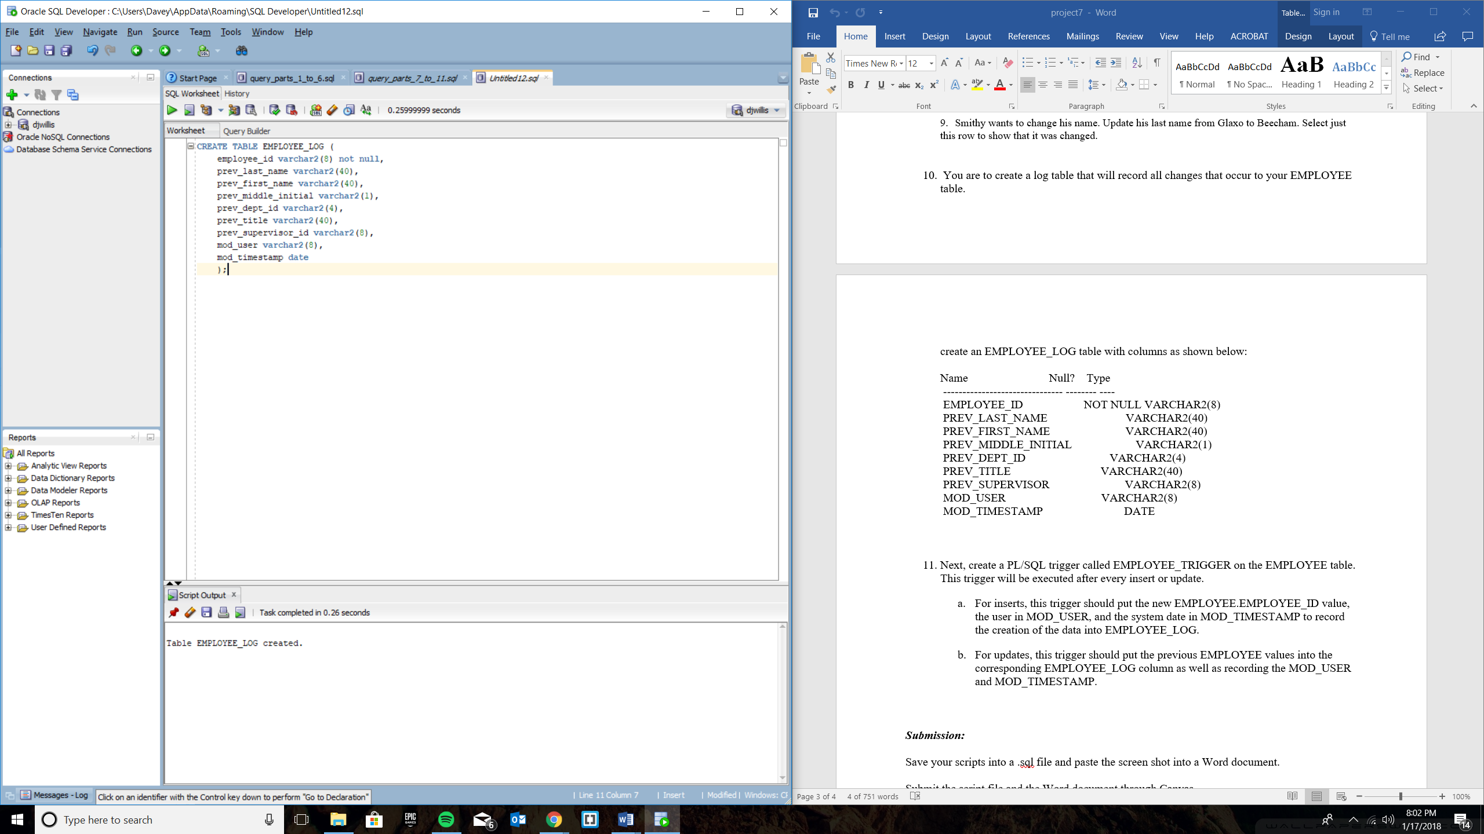

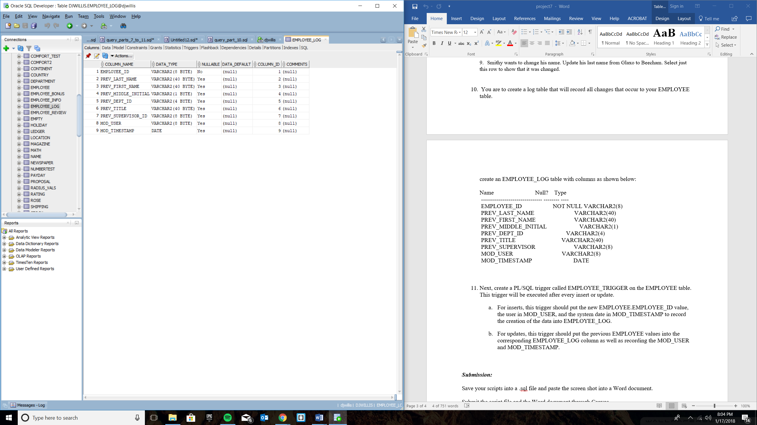

Query Part 11

11 – a

create or replace TRIGGER EMPLOYEE_TRIGGER_INSERT

AFTER INSERT ON EMPLOYEE

FOR EACH ROW

BEGIN

INSERT INTO EMPLOYEE_LOG VALUES (:new.employee_id, :new.last_name, :new.first_name,

:new.middle_initial, :new.dept_id, :new.title, :new.supervisor_id, user, Sysdate);

END;

Proof that INSERT TRIGGER works

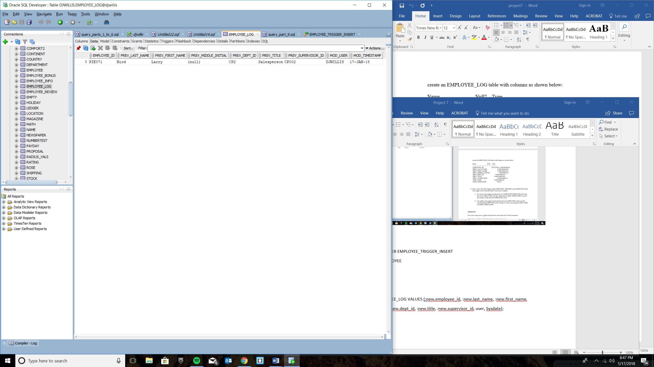

11-b

CREATE OR REPLACE TRIGGER EMPLOYEE_TRIGGER_UPDATE

BEFORE UPDATE ON EMPLOYEE

FOR EACH ROW

BEGIN

INSERT INTO EMPLOYEE_LOG VALUES (:new.employee_id, :old.last_name, :old.first_name,

:old.middle_initial, :old.dept_id, :old.title, :old.supervisor_id, user, Sysdate);

END;

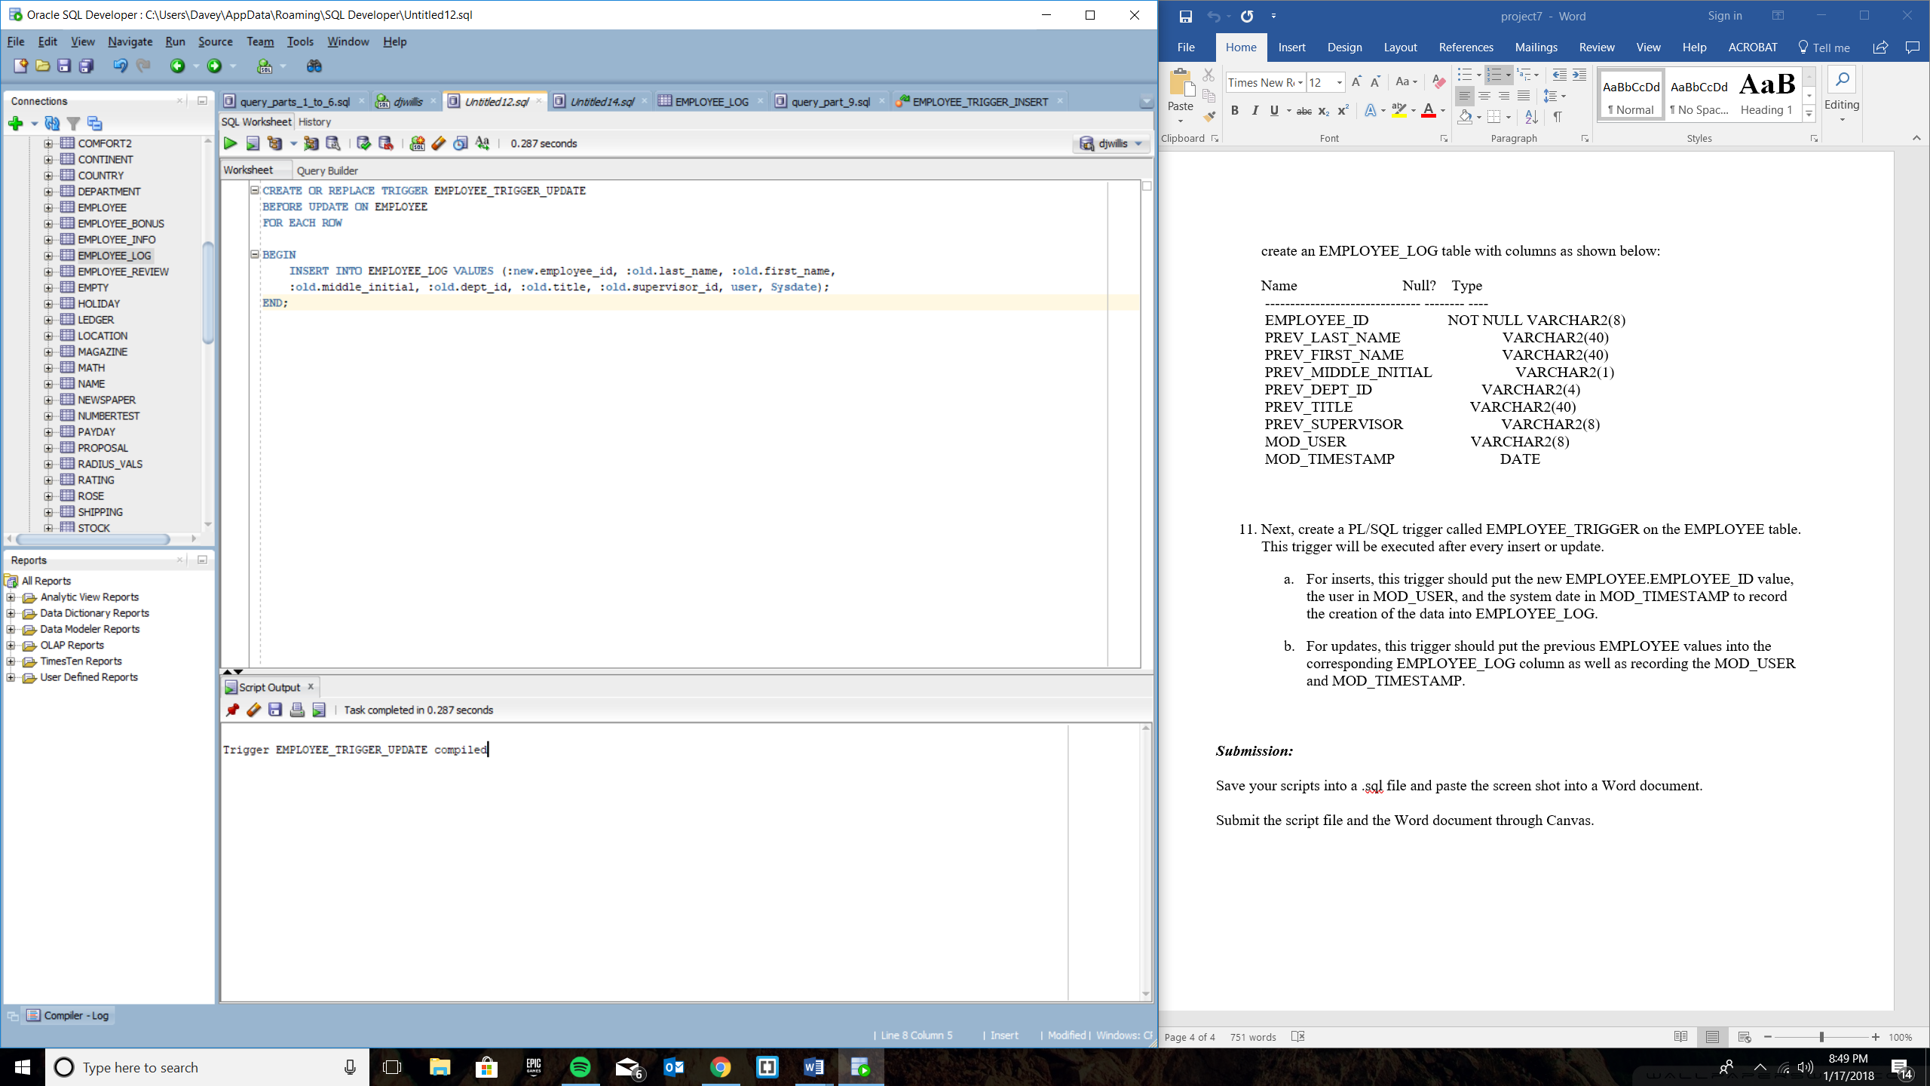

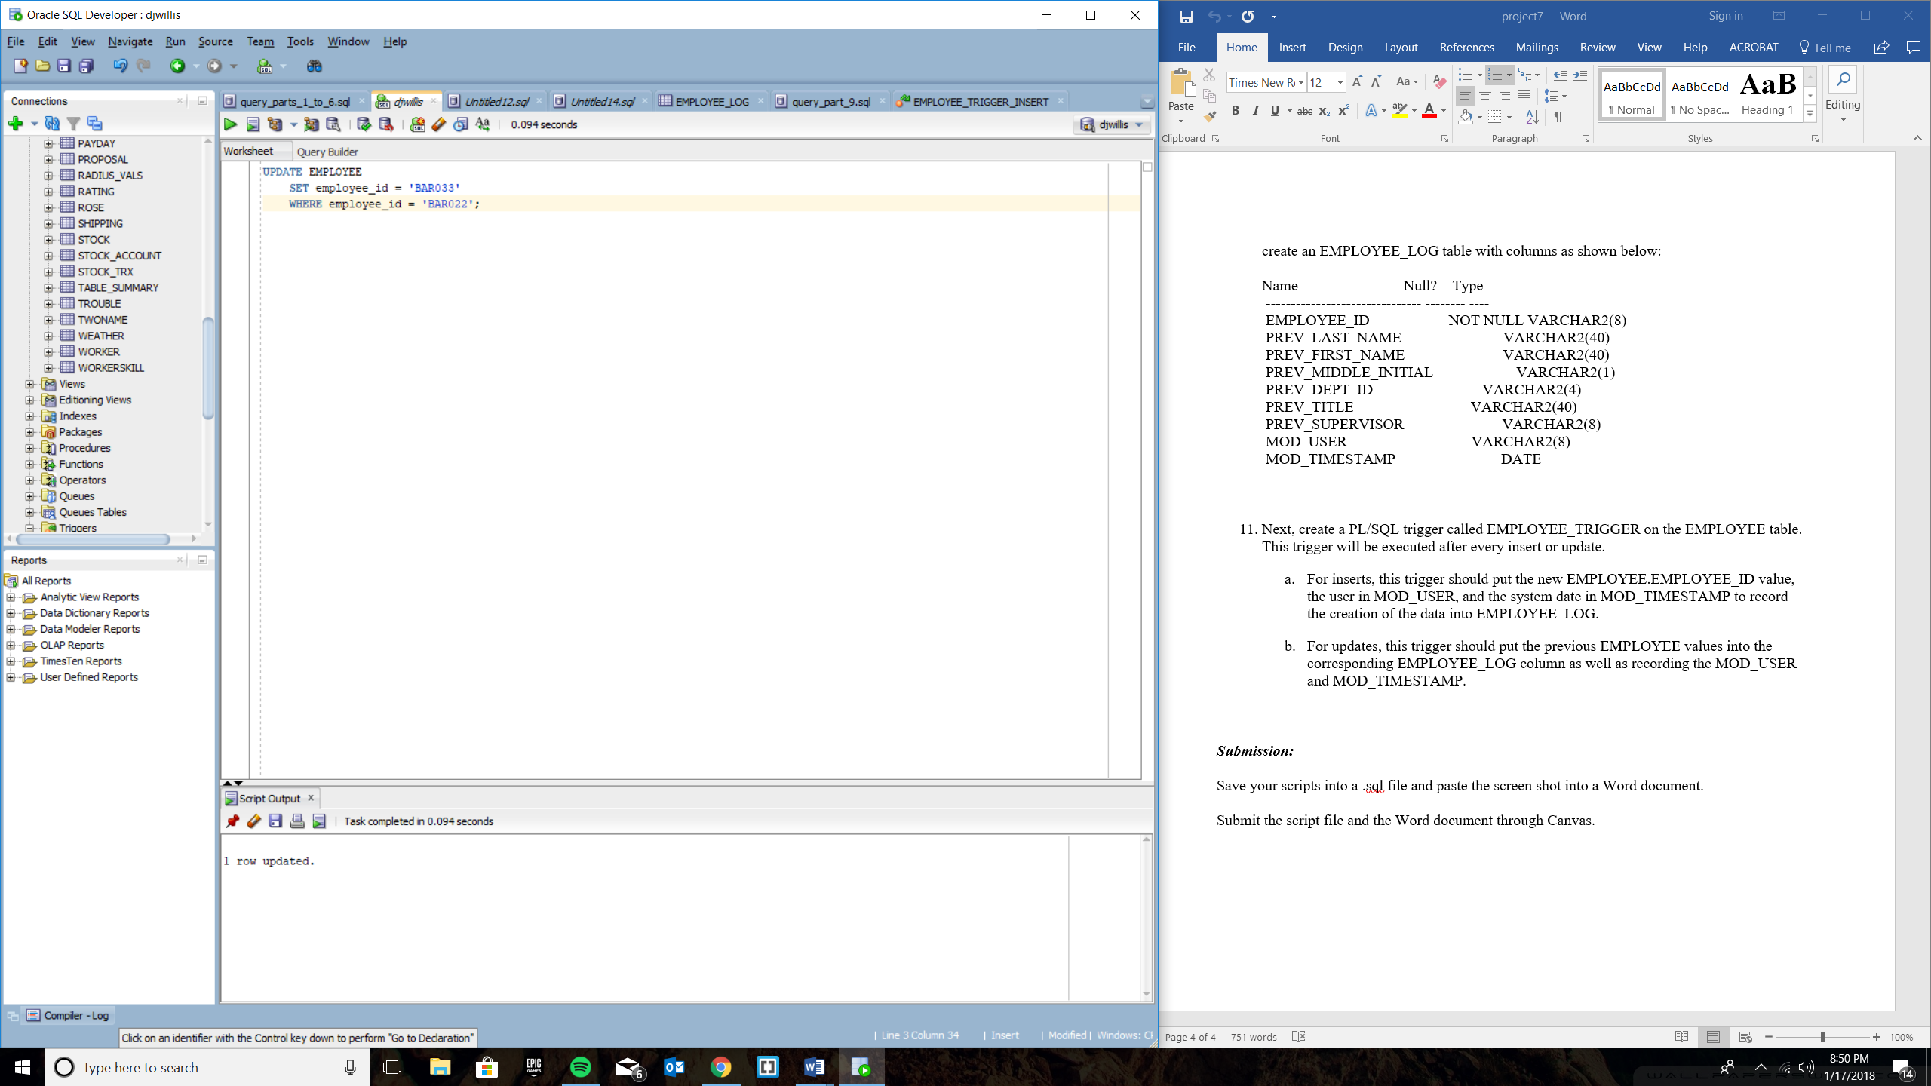

Proof that it worked:

